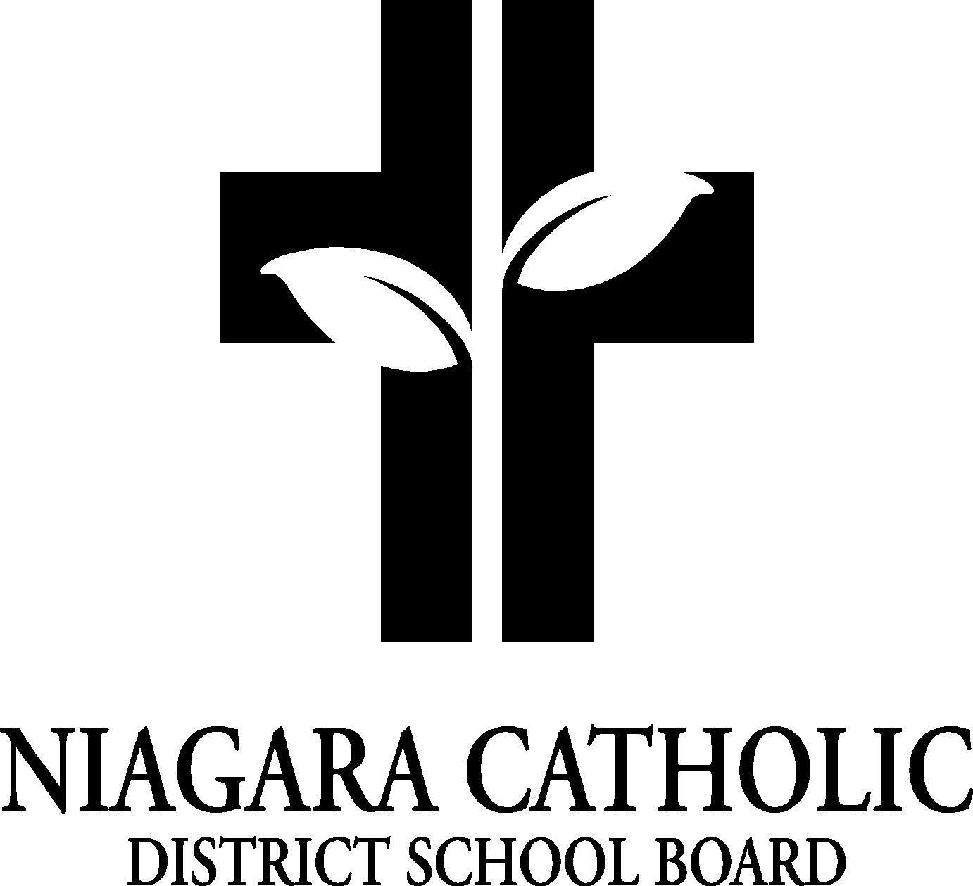
St. Patrick Catholic School Council Minutes September 14, 2023

A. ROUTINE MATTERS: Chair and co-chair will be elected this meeting.

- Opening Prayer – MK Welcome and prayer
Dear Lord, as we begin this new school year, we gather as a community of believers, a family of your children. We thank you for the renewal of the past months and our safe return to this place. We thank you for the promise of the days ahead and for the blessing of your accompaniment as you guide us through this new school year.
We ask this prayer through Jesus Christ our Lord. Amen
- Presentation – Fundraising presentations
3. Roll Call

Members | Affiliations | Present | Excused | Absent
Mrs. Maltman | Chair –
Mrs. Maloney | Co-Chair –
 | Secretary/Treasurer-Principal
 | Recording Secretary – Principal
Mrs. Peazel, Ms. Smyth | Teacher Representative –
 | Non-Teaching Representative – Ralph Caperchione
 | Parish Representative – Father Wes
Parent Representatives and email address
Mrs. Stivoric | j.k.stivoric@gmail.com
Mrs. Anna Simpson | kfn22@yahoo.ca
Mrs. Maltman | leeannmaltman@gmail.com
Mrs. Eckert | jessicarmt4@gmail.com
Mrs. Herbert | herbertclmw@gmail.com
 | meaghanbodis@gmail.com
Mrs. Maloney

5. Approval of the Agenda

Moved by the committee
THAT the St. Patrick Catholic School Council approve the Agenda of the St. Patrick Catholic School Council Meeting on Thursday September 14, 2023
CARRIED

6. Disclosure of Interest - NONE


AGENDA

7. PRESENTATIONS- None

8. PRINCIPAL’S REPORT
- Elections of the Chair and Co-Chair:
The roles from last year were reviewed. The members agreed that Leeann Maltman will be chair and Jen Maloney will be co-chair. All members introduced themselves and emails were gathered so that emails can be sent to all council members.
  - Thanksgiving lunch at the church hall on Wednesday Oct 4. Need volunteers from 10:30 to 11:30. Every student will pay through school Cash on line. Lemayzz agreed to prepare the lunch similar to last year. Volunteers will help to pass out the meals. A question was brought up where the council could provide the luncheon. In the past, there would be a $2.00 donation. The regulation around food changed around the Covid. Lamayzz is insured and providing the cooked food is beneficial.
  - Mass begins the event, then as a school, we meet in the hall for a meal. Parents volunteer to help serve it. Last year it was $7.00 per family. As a council, how we can use the fundraising money from last year, we can decide. Lamayzz is available to do it, and the council agreed with Lamayzz. We are including corn and carrots this year. Next meeting, we can look at pancakes.

- Future Fundraising ideas – The calendar with gift cards. We raised $4200.00 for selling 420 calendars. We also talked about doing a Krispy Crème donut fundraiser in the Spring?
- We are looking at how the fundraising can be used for students. Ex. Thanksgiving Luncheon, Shrove Tuesday or class trip help. The placemats are important to be included as part of the Luncheon tradition. Staff will have to be reminded of this placemat tradition.
- Popcorn sales through the student council will help with Camp Madeba. We will proceed with the Big Box Sale of Cards. Any other suggestions can be emailed to Mrs. Kalagian.

9. NEW BUSINESS/QUESTION

10. NEXT MEETING: Next meeting, we can look at pancakes for Shrove Tuesday. Pasta Day once a month on Tuesday, Archie’s Day, Pita Day and Pizza Day are the food days for the school year. Pizza day will be the last two Friday’s in September.
Thanksgiving Parent Volunteers:
Mrs. King, Mrs. Eckert, Mrs. Maloney, Mrs. Maltman, Mrs. Stivoric, Mrs. Tyminski

11. ADJOURNMENT Mary Kay Kalagian

This meeting was adjourned at 6:14 pm
12. CLOSING PRAYER: Mary Kay Kalagian
Almighty God, we started this meeting with you, and we are closing it with you. Thank you for everyone in attendance for their support, collaboration and respect. Please guide everyone safely home. We ask this through Christ our Lord. Amen

